Extent and Quality of Interface in Cellulose-PE Nanocomposites

Mauro Zammarano^{a,c,d♣}, Paul H. Maupin^{b, ♣}, Li-Piin Sung^{c}, Jeffrey W. Gilman^{d}, Edward D. McCarthy^{d♣}, Yeon S. Kim^{c♣}, and Douglas M. Fox^{a, ♣}

ª Department of Chemistry, American University, Washington DC, 20016, USA.

^{b} Chemical Sciences, Geosciences, and Biosciences Division Office of Basic Energy Sciences, U.S. Department of Energy, Washington, DC 20585-1290.

^{c} Engineering Laboratory, ^{d} Materials Measurement Laboratory, National Institute of Standards and Technology, 100 Bureau Drive, Gaithersburg, MD 20899-8665, USA.
♣ Guest researcher at /NIST.

INTRODUCTION
One of the most enduring problems in the evolution of science and technology using nanoscale materials is the characterization of their morphology in macroscopic systems.¹ This involves spatial and orientation distribution, which may be multimodal and hierarchical, and requires information from the nano- to the macroscale, i.e., over six orders of magnitude in length scale. Several techniques have been developed for characterizing the morphology of polymer nanocomposites, but none of them is a stand-alone method, capable of addressing all these requirements simultaneously; thus, a multitude of techniques is generally necessary. Furthermore, the properties of the interface can be significantly different from the ones of the bulk. Here we show, how FRET combined with laser scanning confocal microscopy, LSCM, can be used to monitor amount and quality of interface formation at a nanoscale through an easily accessible method that is amenable to high throughput testing.

Results and Discussion
FRET is a process by which a fluorophore (the donor), in an excited state, transfers its energy to a neighboring molecule (the acceptor) by non-radiative dipole-dipole interaction.^{2,3} The energy transfer efficiency between a donor and acceptor at a distance R decreases sharply with R: it is equal to 50 % for R=R₀ (where R₀ is the Förster distance) by definition. Typical values of R₀ are between 2 nm and 6 nm, thus the FRET efficiency is typically negligible for R>10 nm. In a composite, where both the reinforcing phase and the matrix are fluorescently labeled, FRET occurs only at a distance of a few nm from the interface, revealing the interface itself. This implies that FRET can encode in optical microscopy nano-features (i.e., extent of interface formation), which are beyond the resolution limit of optical microscopy (Abbe limit). By combining optical microscopy techniques (e.g., LSCM) with FRET, one can probe an area that is large enough to be representative of the entire sample (macroscale) and still retain information at a smaller scale (nanoscale). Fig. 1. shows donor, acceptor fluorescence and energy-transfer-efficiency maps calculated by FRET analysis at 5x and 100x magnification for a model system comprised of nanofibrillated cellulose, NFC, labeled with a fluorescein dye (FLNFC),⁵ in a polyethylene, PE, matrix with Coumarin 30, C30. The average energy-transfer-efficiency was N_{FRET} = 0.121, this is in contrast to a poorly mixed sample (not shown) with N_{FRET} = 0.018. This reflects the larger extent of interface formation in the more homogeneous sample.

EXPERIMENTAL⁴
Materials: Nanofibrillated cellulose, NFC, (Lyocell L040-6, length of 6 mm and nanofibrils with a diameter 50 nm to 500 nm) from Engineered Fibers Technology (Shelton, CT). Fluorescent dyes, Coumarin 30 (C30) and 5-(4,6-dichlorotriazinyl)aminofluorescein (FL), were purchased from Sigma-Aldrich (Milwaukee, WI) and Invitrogen (Carlsbad, CA), respectively. Medium density polyethylene (PE), with M_{n} ≈ 1800⁵ and a density of 0.94 g/cm³, was supplied by Scientific Polymer Products (Ontario, NY).
Sample Preparation. NFC was labeled with fluorescein using the method of Helbert et al.⁶ PE composite samples were prepared by extrusion in a micro-compounder (DACA Instruments, Santa Barbara, CA) at 108º C and residence time 5 min. A concentrated batch containing 2 %⁷ of C30 in PE was prepared and then re-extruded to obtain samples with a 0.19 % final concentration of C30 and/or 5 % FLNFC.
LSCM. A laser scanning confocal microscope (LSM 510 META Carl Zeiss, Germany) was used to detect FRET. A software tool (FRET Tool vs 5.0, Carl Zeiss) was used to map and quantify the FRET efficiency.

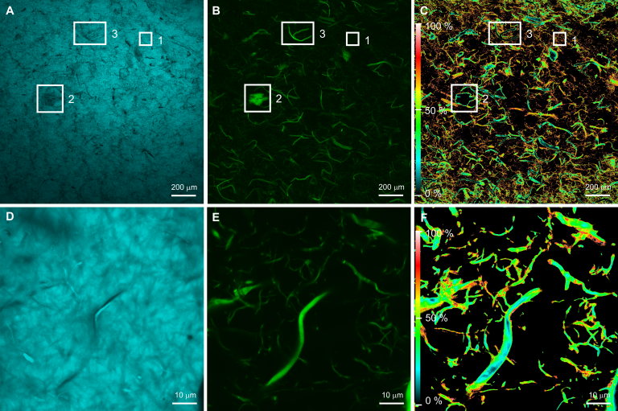
Figure 1. LSCM false color images for PE-C30+FLNFC: (A) C30 fluorescence (donor filter set) at 5x magnification; (B) FLNFC fluorescence (acceptor filter set) at 5x; (C) energy-transfer-efficiency map calculated according to the N_{FRET} algorithm at 5x (N_{FRET} = 0.121); (D) C30 fluorescence at 100x; (E) FLNFC fluorescence at 100x; (F) energy-transfer-efficiency map at 100x.

CONCLUSIONS
FRET/LSCM provides a powerful tool with unique features for the morphological characterization of polymer nanocomposites across many length scales, such as nanoscale information about interface formation based on FRET, meso- and macroscale information with orientation and spatial information based on LSCM three-dimensional visualization. Temperature controlled experiments can be also used to measure the glass transition temperature at the interface and the bulk polymer as well.

ACKNOWLEDGEMENTS
Financial support was provided by the Air Force Office of Scientific Research (JWG), and NIST (JWG, DMF, MZ).

REFERENCES
1. Krishnamoorti R. Strategies for Dispersing Nanoparticles in Polymers. MRS Bul., 2007, 32, 341-346.
2. Förster T. Intermolecular Energy Migration and Fluorescence. Ann. Phys. 1948, 2, 55-75.
3. Lakowicz J.R. Energy transfer. In Principles of Fluorescence Spectroscopy 3d edition, Springer, New York, 1999, 443-506.
4. This work was carried out by the National Institute of Standards and Technology (NIST), an agency of the U. S. government and by statute is not subject to copyright in the United States. Certain commercial equipment, instruments, materials, services, or companies are identified in this paper in order to specify adequately the experimental procedure. This in no way implies endorsement or recommendation by NIST.
5. According to ISO 31-8, the term “molecular weight” has been replaced by “relative molecular mass,” symbol M_{r}. Thus, if this nomenclature and notation were to be followed in this publication, one would write M_{r,n} instead of the historically conventional M_{n} for the number average molecular weight. The conventional notation, rather than the ISO notation, has been employed for this publication.
6. Helbert W.; Chanzy H.; Husum T.L.; Schülein M.; Steffen E. Fluorescent Cellulose Microfibrils As Substrate for the Detection of Cellulose activity, Biomacromolecules, 2003, 4, 481-487.
7. % is used throughout this manuscript and is identical to % by mass.

